When we try to read image with OCR engine there are irregularity in result the desired result is not obtained and the value read by the OCR engine are also false below are the observations:

Input:

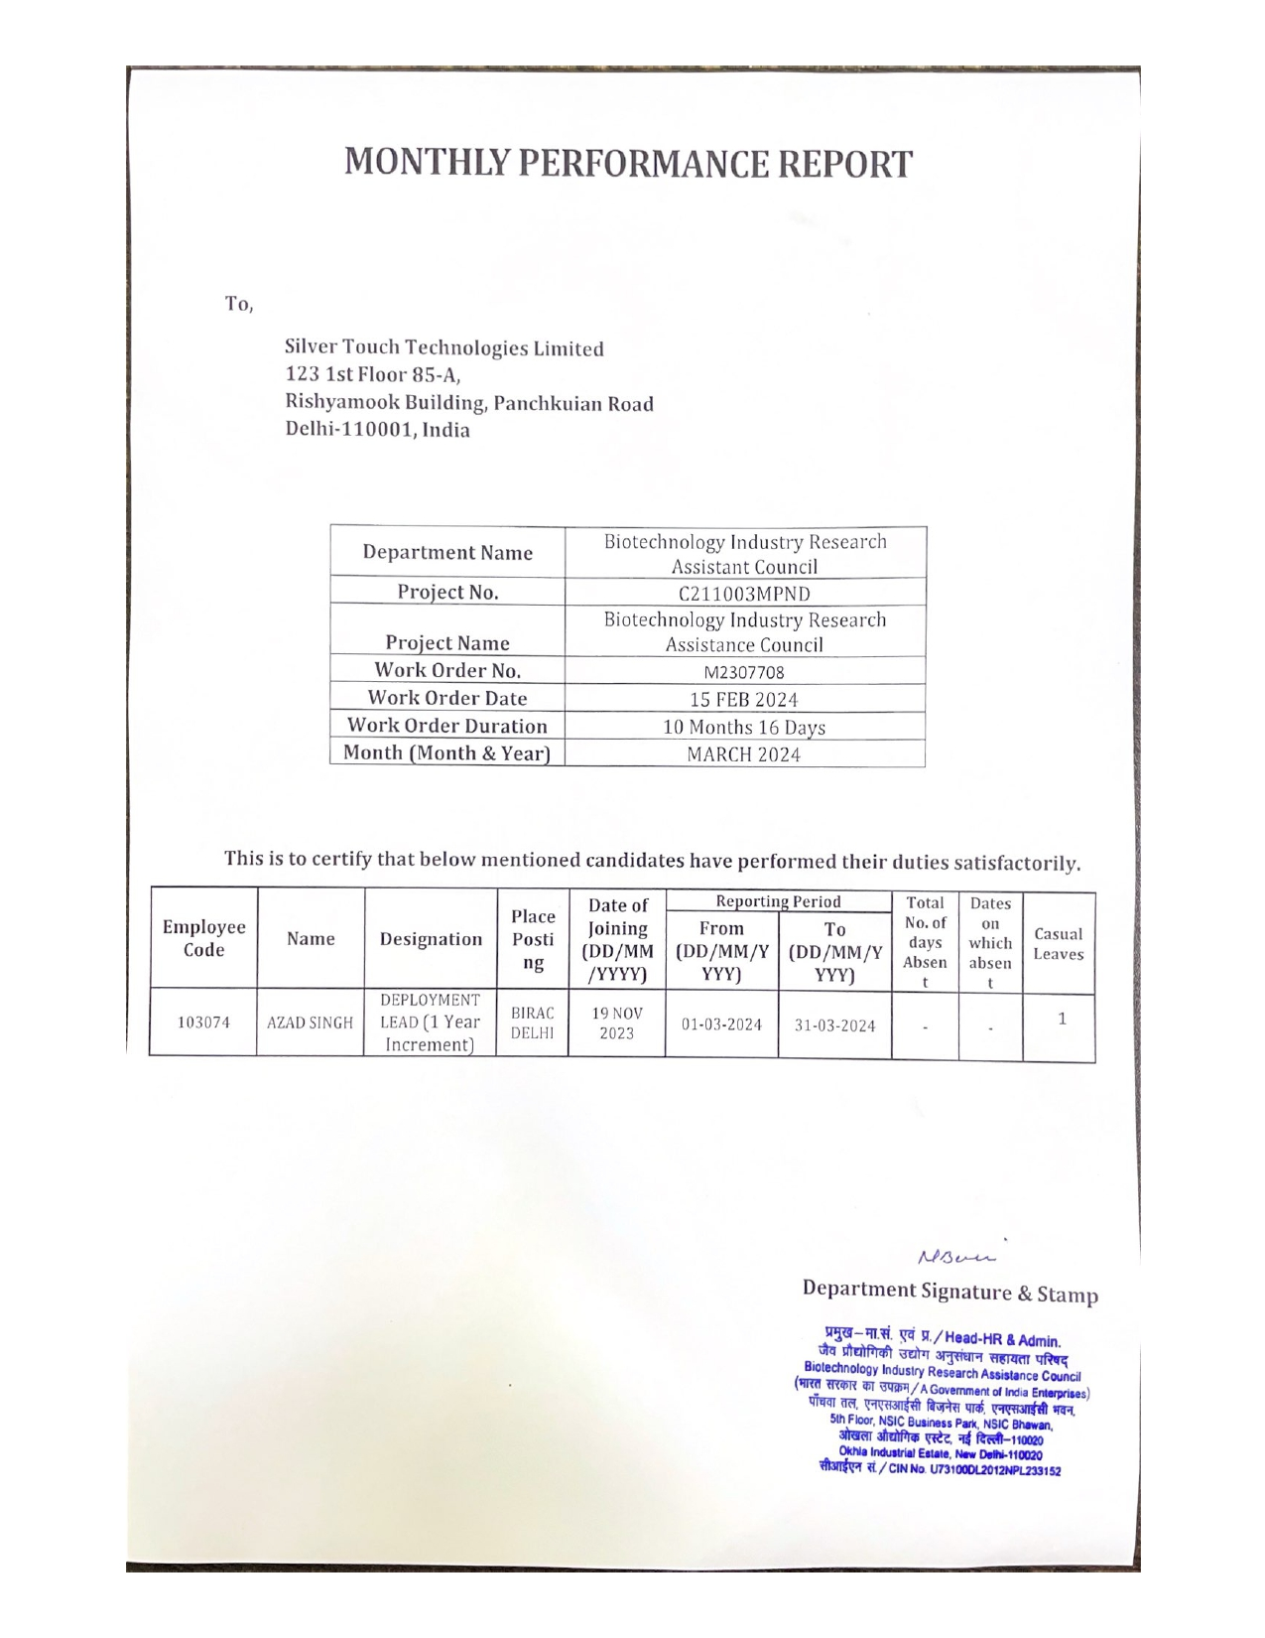

Output using Windows OCR engine:

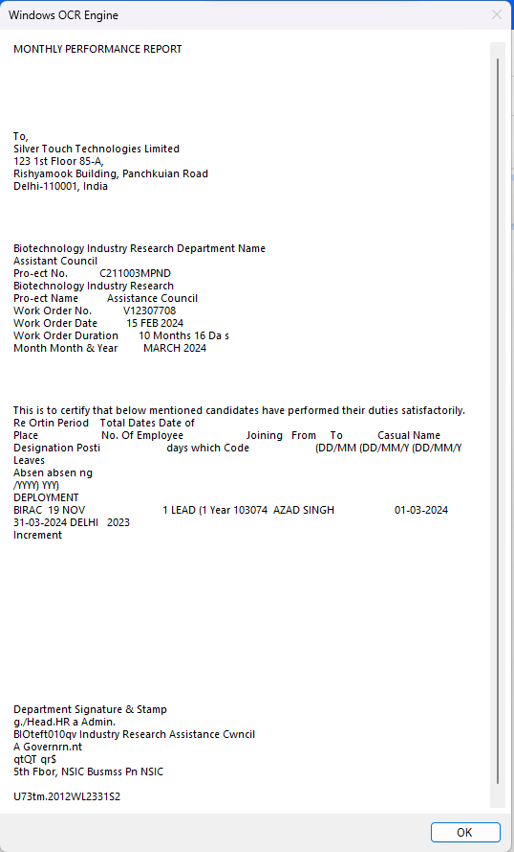

Output

